TITLE: INTEGRATED SYNTHESIS OF THE PERMIAN BASIN: DATA AND MODELS FOR RECOVERING EXISTING AND UNDISCOVERED OIL RESOURCES FROM THE LARGEST OIL-BEARING BASIN IN THE U.S.

SEMI-ANNUAL TECHNICAL REPORT

Reporting Period: 4/1/05 – 9/30/05

Author: Stephen C. Ruppel

March 2006

Contract No. DE-FC26-04NT15509

Contractor Name and Address:
Bureau of Economic Geology, John A. and Katherine G. Jackson School of Geosciences, The University of Texas at Austin, Austin, TX 78713-8924
DISCLAIMER
This report was prepared as an account of work sponsored by an agency of the United States Government. Neither the United States Government nor any agency thereof, nor any of their employees, makes any warranty, express or implied, or assumes any legal liability or responsibility for the accuracy, completeness, or usefulness of any information, apparatus, product, or process disclosed, or represents that its use would not infringe privately owned rights. Reference herein to any specific commercial product, process, or service by trade name, trademark, manufacturer, or otherwise does not necessarily constitute or imply its endorsement, recommendation, or favoring by the United States Government or any agency thereof. The views and opinions of authors expressed herein do not necessarily state or reflect those of the United States Government or any agency thereof.
SEMI-ANNUAL TECHNICAL REPORT

for

INTEGRATED SYNTHESIS OF THE PERMIAN BASIN: DATA AND MODELS FOR RECOVERING EXISTING AND UNDISCOVERED OIL RESOURCES FROM THE LARGEST OIL-BEARING BASIN IN THE U.S.

Contract No. DE-FC26-04NT15509

Table of Contents
Disclaimer ii
Introduction 1
Executive Summary 2
Results and Discussion 2
Significant Accomplishments 4
Problems and Delays 4
Program Additions 4
Industry Involvement and Supplemental Funding 5
Current Project Staff 5
Technology Transfer Activities 7
Future Work 8

List of Figures

1. Map of West Texas and New Mexico showing area encompassed by project 1

Introduction
This report describes the work accomplished during months 7 through 12 of the project, a synthesis of geological data and models for the Permian Basin of West Texas. A map of the area covered by the study is displayed as figure 1. We have continued to make excellent progress toward project goals and objectives.
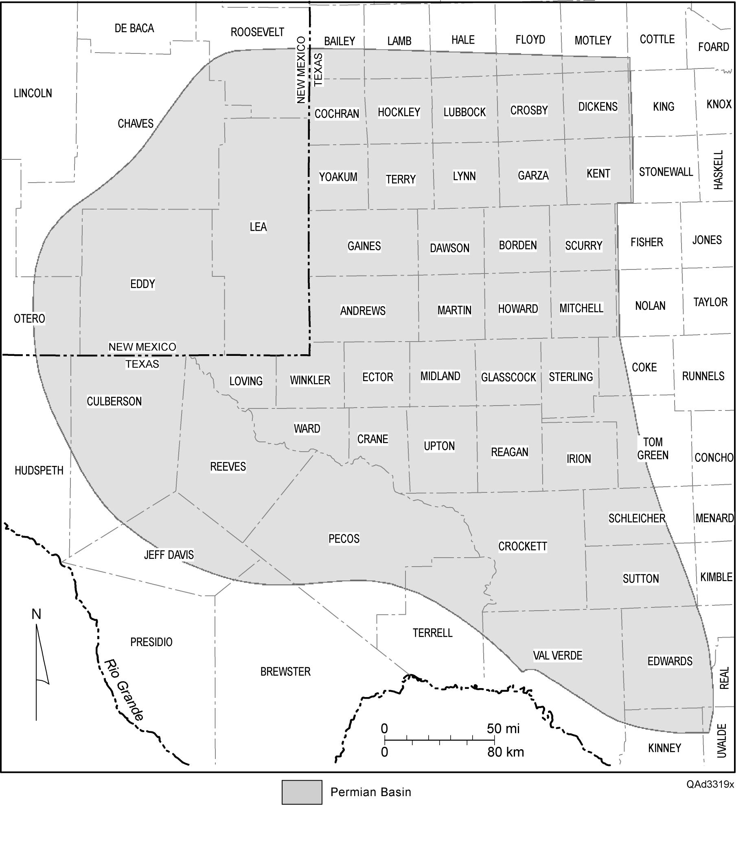
Figure 1. Map of West Texas and New Mexico showing area encompassed by project.

Executive Summary
During the second six months of the project, work has continued to focus on preparation of written summaries of the geology of major hydrocarbon-producing systems in the Permian Basin. Work is now under way on 17 of the 24 targeted summaries. Data collection is also now well under way. Efforts are being focused on three plays: the Lower Devonian Thirtyone Formation, the Upper Devonian Woodford Formation, and the Mississippian Barnett Formation.
Five companies (two majors and three independents) have become project sponsors and have provided supplementary funding of $130,000. Five additional companies have expressed a desire to join. In addition, Geological Data Services Company (GDS) has agreed to provide in-kind project support in the form of stratigraphic tops data for the entire Permian Basin study area.
We have established a new collaborative arrangement with the Bureau of Economic Geology’s State of Texas Advanced Resource Recovery (STARR) project. This effort has resulted in the addition of funding and four new staff members in the areas of petrophysics, reservoir engineering, and fracture characterization. The specific focus of these staff is the Barnett and Woodford gas shales resource plays—two of the hottest exploration plays in the region.
Although the project is in early phases of data collection and synthesis, we are already conducting technology transfer activities to disseminate project data and results to the industry.

Results and Discussion
During the second six months of the project, we continued to split our efforts between two tasks: (1) the preparation of written summaries for each major hydrocarbon reservoir succession in the Permian Basin, and (2) the collection, integration, and loading of available data into an ArcGIS project for dissemination to interested users.
Progress on written summaries is excellent. We are currently planning to write 24 reports on specific reservoir plays in the Permian Basin. Authors have been assigned to plays, and 17 of the reports are under way: the Lower Ordovician Ellenburger Group, the Middle Ordovician Simpson Group, the Upper Ordovician Montoya Group, the Ordovician-Silurian Fusselman Formation, the Upper Silurian Wristen Group, the Lower Devonian Thirtyone Formation, the Upper Devonian Woodford Formation, the Mississippian Barnett Formation, the Pennsylvanian Morrow, Atoka, Strawn, Canyon, and Cisco Groups, the Leonardian slope carbonate succession, the Guadalupian San Andres Formation, the upper Guadalupian Artesia Group, and the Guadalupian Spraberry/Dean deepwater clastics succession.
Data collection is also proceeding smoothly. Our primary efforts in data collection are being focused on three reservoir plays that are of current interest among developers and explorationists in the Permian Basin: the Thirtyone Formation, the Woodford Formation, and the Barnett Formation. Data are being collected, checked for accuracy, and loaded into an ArcGIS project. We are also continuing our data collection and study of the Barnett shale play in the Fort Worth Basin. This work is critical to understanding the developing gas resource play in the Barnett in the Permian Basin, as very few data are available in the Permian Basin. We have discovered and have begun to analyze 25 cores that have penetrated the Barnett section in the Fort Worth Basin area. These cores, which have not been previously seen or characterized, will provide key information on the Barnett across both the Permian and Fort Worth Basins.
Finally, we are continuing to collect wireline log rasters across the Permian Basin area. These raster logs are forming the basis for regional correlations and will help provide a correlation framework for operators in the area. An important adjunct to this work is the stratigraphic tops data provided by Geological Data Services Company (GDS). GDS has provided complete stratigraphic tops for more than 6,000 wells across the Permian Basin study area. These tops will help integrate our work with the commercially available stratigraphic studies performed by GDS using more than 200,000 wells across the Permian Basin.

Significant Accomplishments
We have already completed written summaries of four major reservoir successions: the Fusselman (lower Silurian) shallow water platform carbonates play, the Wristen (upper Silurian) shallow water platform carbonates play, the Thirtyone deep water chert play, and the Upper Devonian Woodford shale formation. These reports are undergoing final editing and will be distributed soon. We have also collected significant data (such as core analysis reports, lists of publications, core descriptions, cross sections, poster presentations, etc.) on the Thirtyone succession, which are being prepared for distribution, Other data being prepared for early distribution include lists of available cores at the Bureau of Economic Geology for the Barnett, Woodford, and Thirtyone Formations.

Problems and Delays
No problems or delays have been experienced.

Program Additions
We have acquired access to additional funding that will allow the project to expand its scope to include a greater area. Funding made available from the STARR project at the Bureau of Economic Geology has made it possible to increase our area of study, add staff, and expand project objectives and deliverables.

Industry Involvement and Supplemental Funding
We currently have five industry sponsors: BP, Oxy, Samson, Osborne Heirs, and Alpine. This is a perfect mix of the large and small companies that are currently active in the Permian Basin. These companies provide additional funds for project activities and help set priorities for studies. They also assure that project activities will be focused on the needs of both large and small operators in the Permian Basin. Five additional companies have expressed an interest in becoming sponsors: Chevron, Yates, Kinder Morgan, Whiting, and Encana. The STARR program at the Bureau of Economic Geology is also providing staff and funding to carry out many project activities.
GDS has also joined the project and has provided complete stratigraphic tops for more than 6,000 wells across the Permian Basin study area. These tops are important guides to our regional correlation work.

Current Project Staff
To increase our effort and expertise on the project, we have added new staff to the team. Dr. Wayne Wright (new with the Bureau) has specific experience in Carboniferous depositional systems worldwide. His early focus on the project is a synthesis of the Pennsylvanian System. Dr. Edgar Guevara (18 years of experience at the Bureau and more than 35 years of experience in clastic reservoir systems worldwide) has started work on a synthesis of the basinal Dean and Spraberry successions in the Midland Basin and will also work on the Delaware Mountain Group in the Delaware Basin. Seay Nance (22 years of experience at the Bureau) is working on upper Guadalupian platform and basin successions (e.g., Queen, Yates, Delaware Mountain Group). A list of project staff follows:

Dr. Stephen Ruppel, Project leader
Primary focus: Fusselman, Wristen, Thirtyone, Barnett, Wolfcamp platform, Leonardian platform, San Andres, Grayburg
Dr. Robert Loucks, Co-PI
Primary focus: Ellenburger, Woodford, Barnett
Dr. Charles Kerans
Primary focus: San Andres, Grayburg
Dr. Wayne Wright
Primary focus: Atoka, Morrow, Strawn, Canyon, Cisco
Dr. Edgar Guevara
Primary focus: Dean, Spraberry, Delaware Mountain Group
Seay Nance
Primary focus: Grayburg, upper Guadalupian (Queen, Yates, etc.), Delaware Mountain Group
Dr. Frank Brown
Primary focus: Pennsylvanian
Dr. Julia Gale
Primary focus: Fracture characterization
Dr. Fred Wang
Primary focus: Reservoir engineering of the Barnett
Dr. Jeff Kane
Primary focus: Petrophysics
Dr. Shinichi Sakurai
Primary focus: Petrophysics
Rebecca Jones
Primary focus: Simpson, Montoya
Ted Playton
Primary focus: Wolfcamp/Leonard basin/slope
Graduate Students (2)
Primary focus: Data collection, log correlations, Barnett, Woodford, Thirtyone

Technology Transfer Activities
We have begun planning for a technology transfer meeting to be held in early 2006. This meeting will consist of one day of oral presentations on major hydrocarbon-bearing successions in the Permian Basin and a one-day core and poster workshop. The oral presentations will be used to provide summary overviews of key aspects of important reservoir systems. The core/poster workshop will give participants a chance to get hands-on experience with the rocks from which these reservoirs produce.
Three papers were presented at the national meeting of the American Association of Petroleum Geologists (AAPG) in Calgary in June 2005 documenting important aspects of Permian Basin reservoir systems. Dr. Frank Brown presented a poster titled “Upper Pennsylvanian and Lower Permian Sequence Stratigraphy and Depositional Systems Tracts, Intracratonic Eastern Shelf and Adjacent West Texas Basin, North- and West-Central Texas.” Dr. Stephen Ruppel presented a poster titled “Multidisciplinary Reservoir Characterization of a Giant Permian Carbonate Platform Reservoir: Insights for Recovering Remaining Oil in a Mature U.S. Basin” and a talk titled “Surprising Lessons from Multidisciplinary Characterization of a Permian Carbonate Platform Reservoir.” The latter papers stem from work recently funded by DOE under contract DE-FC26-01BC15351.
Drs. Stephen Ruppel, Bob Loucks, and Rob Reed will present the results of their studies of the Barnett Formation at the South Central meeting of the Geological Society of America in March 2006. The goals of these presentations are (1) to present initial results of our regional studies of the Barnett, an important gas-shale succession that is of widespread interest throughout the region, and (2) to develop additional industry contacts who may be interested in supporting and contributing to the project. Dr. Reed’s paper is titled “Preliminary Fracture Analysis of Mississippian Barnett Shale Samples, Fort Worth Basin, Texas.” Dr. Loucks will talk on “Sedimentology and Depositional Setting of the Mississippian Barnett Shale, Wise County, Texas.” Dr. Ruppel will speak on “Stratigraphy and Depositional History of the Barnett Formation and Equivalent Mississippian Rocks in the Fort Worth Basin.”
Dr. Ruppel will also present a summary of core-based studies of the Leonardian Clear Fork Group reservoir system in the Permian at the AAPG annual meeting in April 2006 in Houston. His posters are titled “Fundamentals of Rock-based Reservoir Modeling: A Case History from the Lower Permian Fullerton Field, Permian Basin” and “Key Role of Outcrops and Cores in Carbonate Reservoir Characterization and Modeling, Lower Permian Fullerton Field, Permian Basin, USA.” Dr. Shirley Dutton will give an oral presentation at the AAPG meeting on Permian Basin reservoirs titled “Oil-Play Analysis of the Permian Basin: A Tool for Increasing Recovery from a Mature Oil-Producing Province.”

Future Work
Work will continue through the end of the year on compilation, synthesis, and writing of comprehensive summaries of individual Paleozoic reservoir systems in the Permian Basin. We hope to complete and distribute written summarizes by early 2006. We will also continue to expand our focused studies of the Barnett and Woodford Formations—the two successions of greatest interest to gas resource explorers and developers at present.
We plan to construct a Web site by year’s end that will provide the basis for distributing data and information to oil and gas companies and others interested in Permian Basin geology and hydrocarbon resources.

