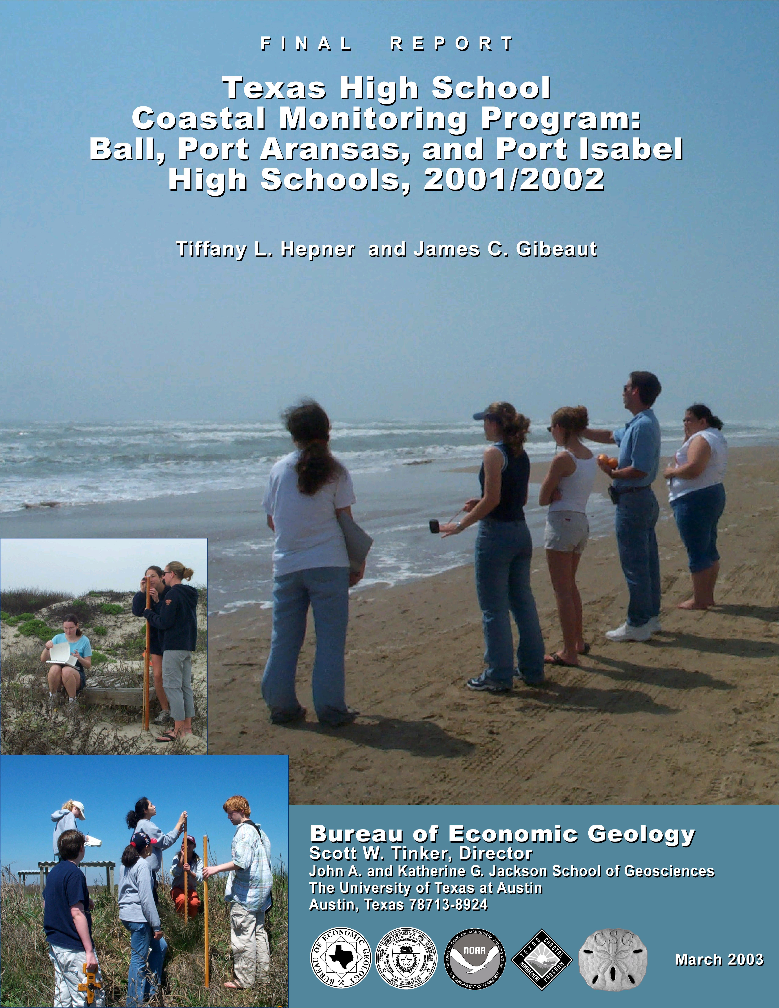
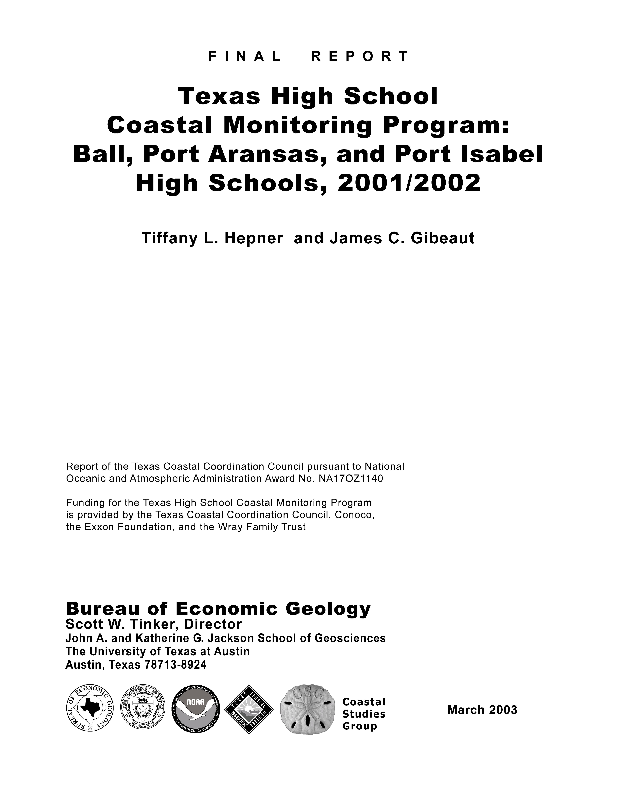
CONTENTS

INTRODUCTION 1
PROGRAM DESCRIPTION 2
Goals 2
Methods 3
Training 3
Data Management, Data Analysis, and Dissemination of Information 4
STUDENT, TEACHER, AND SCIENTIST INTERACTIONS DURING THE 2000-2001 ACADEMIC YEAR 4
Ball High School 5
Port Aransas High School 6
Port Isabel High School 6
Effects on Science Curriculum 8
Effects on Scientific Research, Coastal Management, and Public Awareness 9
SCIENTIFIC RESULTS OF 1997-2001 STUDIES 10
CONCLUSIONS 13
Recommendations 13
Appendix A: PROFILE INFORMATION 16
Appendix B: graphs of Volume, Shoreline, and Vegetation-line change 18
APPENDIX C: graphs of BEACH PROFILES 22
INTRODUCTION

The Texas Coastal Monitoring Program engages people who live along the coast in the study of their natural environment. High school students, teachers, and scientists work together to gain a better understanding of dune and beach dynamics on the Texas coast. Scientists from The University of Texas at Austin (UT) provide the tools and training needed for scientific investigation. Students and teachers learn how to measure the topography, map the vegetation line and shoreline, and observe weather and wave conditions. By participating in an actual research project, the students obtain an enhanced science education. Public awareness of coastal processes and the Texas Coastal Management Program is heightened through this program. The students’ efforts also provide coastal communities with valuable data on their changing shoreline.

This report describes the program and our experiences during the 2001-2002 academic year. During this time, Ball High School on Galveston Island completed its fourth year in the program, and Port Aransas and Port Isabel High Schools completed their second year (Fig. 1). All three high schools are continuing the program during the 2002-2003 academic year. Discussions of the data collected by the students and recommendations for future high school projects are also included in this report. A manual with detailed field procedures, field forms, classroom exercises, and teaching materials was prepared during the first year of the project at Ball High School in 1996-1997 and revised during subsequent years. The program is also enhanced by a continuously updated Web site (http://inet1.beg.utexas.edu/thscmp/).

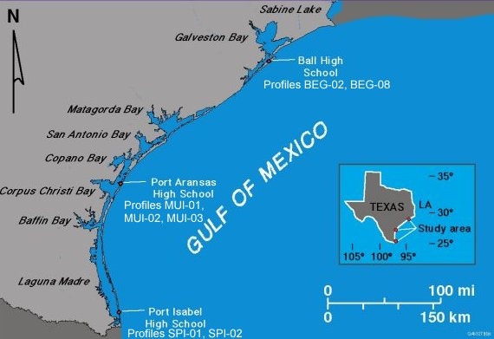

Figure 1. Participating schools.
PROGRAM DESCRIPTION

Goals

The coastal monitoring program has three major goals:

(1) Provide high school students with an inquiry-based learning experience. Students make several field trips to their study sites during the school year. Working in teams, they conduct topographic surveys (beach profiles) of the foredune and beach, map the vegetation line and shoreline, collect sediment samples, and observe weather and wave conditions. Back in the classroom, students analyze their data and look for relationships among the observed phenomena. UT scientists provide background information and guide inquiries about the data, but students are encouraged to form their own hypotheses and to test them. Through their collaboration with working scientists on an actual research project, the students gain an enhanced science education.

(2) Increase public awareness and understanding of coastal processes and hazards. We expect that the participating students will discuss the program with their parents, classmates, and neighbors, further expanding the reach of the program. We also expect the program to attract media attention as it has in the past. A World Wide Web site (http://inet1.beg.utexas.edu/thscmp/) containing the latest information is central to the community outreach portion of the project. Coastal residents may wish to view the effects of a storm that strikes the upper coast. They are able to do so by accessing the Texas Coastal Monitoring Program Web site to view maps, graphs, and photographs collected by Ball High School. Curiosity may drive this inquiry at first, but eventually there is an increased awareness and appreciation of coastal processes and how future storms could affect one’s community.

(3) Obtain a better understanding of the relationship between coastal processes, beach morphology, and shoreline change and make data and findings available for solving coastal management problems. The Bureau of Economic Geology (Bureau) at UT has conducted a 30-year research program to monitor shorelines and investigate coastal processes. An important part of this program is the repeated mapping of the shoreline and measurement of beach profiles. Over time, these data are used to determine the rate of shoreline change. A problem we face is the limited temporal resolution in our shoreline data. The beach is a dynamic environment where significant changes in shape and sand volume can occur over periods of days or even hours. Tides, storms, and seasonal wind patterns cause large, periodic or quasi-periodic changes in the shape of the beach. If coastal data are not collected often enough, periodic variations in beach morphology could be misinterpreted as secular changes. The High School Coastal Monitoring Program helps address this problem by providing scientific data at key locations along the Texas coast. These data are integrated into the ongoing coastal research program at the Bureau and are made available to other researchers and coastal managers.

Methods

The central element in the high school monitoring program is at least three class field trips during the academic year, weather permitting. During each trip, students visit several locations and apply scientific procedures to measure beach morphology and make observations on beach, weather, and wave conditions. These procedures were developed during the program’s pilot year (1997-98) and are presented in detail in a manual and on the Web site that also includes field forms. Following is a general discussion of the field measurements.

(1) Beach profile. Students use a pair of Emery rods, a metric tape, and a hand level to accurately survey a shore-normal beach profile from behind the foredunes to the waterline. The students begin the profile at a presurveyed datum stake so that they can compare each new profile with earlier profiles. Consistently oriented photographs are taken with a digital camera. The beach profiles provide detailed data on the volume of sand and the shape of the beach.

(2) Shoreline and vegetation line mapping. Using a differential Global Positioning System (GPS) receiver, students walk along the vegetation line and shoreline mapping these features for display on Geographic Information System software. The GPS mapping provides measurements of the rate of change.

(3) Sediment sampling. Students take sediment samples along the beach profile at the foredune crest, berm top, and beach face. They then sieve the samples, weigh the grain-size fractions, and inspect the grains using a microscope. These samples show the dependence of sand characteristics on the various processes acting on the beach.

(4) Beach processes. Students measure wind speed and direction, estimate the width of the surf zone, and observe the breaker type. They note the wave direction, height, and period and estimate the longshore current speed and direction using a float, stop watch, and tape measure. From these measurements, students can infer relationships between physical processes and beach changes in time and space. Students also learn to obtain weather and oceanographic data from resources on the Internet.

Training

UT scientists provide the teachers with all the training, information, field forms, and equipment needed to conduct the field and lab measurements. During the school year, UT scientists accompany the students on at least one of the field trips and make at least two classroom visits that may be joined with the field trips. The classroom visits provide students with even more insight into conducting scientific research. The scientists discuss with the students general and theoretical issues regarding scientific research, as well as specific techniques and issues related to coastal research. The visits also provide the scientists with an opportunity to ensure the quality of the data.

Data Management, Data Analysis, and Dissemination of Information

The World Wide Web is central to the dissemination of data collected for this program. A Web site (http://inet1.beg.utexas.edu/thscmp/), which resides on a UT server, was implemented toward the end of the 1998-1999 school year. The Web site provides all the information needed to begin a beach monitoring program, as well as curriculum materials for high school teachers. Each school in the program has an area on the Web site to post its data and observations, including photos taken by an electronic camera. UT scientists manage the data in an electronic database and make it available to the public. UT scientists also evaluate the data in light of coastal management problems. Students and the public can now interactively plot beach profiles and retrieve the data through the Web site.

STUDENT, TEACHER, AND SCIENTIST INTERACTIONS DURING THE 2001-2002 ACADEMIC YEAR

UT scientists, Dr. Gibeaut and Ms. Hepner, worked with teachers Ms. Shawna Riddle of Ball High School, Mr. William Slingerland of Port Aransas High School, and Mr. Kevin Tenison of Port Isabel High School. Ms. Riddle and Mr. Slingerland chose their Aquatic Sciences classes to participate in the program. Mr. Tenison’s Advanced Placement Environmental Science class participated in the program. Approximately 40 students in the 9th, 10th, 11th, and 12th grades actively participated during the 2001-2002 school year.

UT scientists visited each school at least twice. These visits coincided with field trips. During and after field trips and during lectures, UT scientists discussed careers in science and university life with students. These visits by UT scientists served not only to enhance scientific instruction, but they also gave students insight into science as a career.

During the field trips, the students were divided into two or three teams, depending on the size of the class. One team measured the profile and took sediment samples while the other team collected data on the weather and waves and conducted a GPS survey of the shoreline and vegetation line. Team members had specific tasks, and students took turns performing them. After each team completed its tasks at the first location, the teams switched roles so that everyone would have an opportunity to conduct all measurements. Sediment sampling was conducted only if the teacher planned to use the sediments in a lab exercise.

Dividing students into two five- to seven-member teams, one that conducts the profile and sediment sampling and the other that measures the processes and the shoreline, works well. Each team finishes at about the same time, although for short profiles, the profiling team may finish early. In this case, an extra task can be assigned to the profiling team. It is important to assign each student a job to keep him or her focused and interested. Time for a little fun should also be allowed. People normally think of the beach as a place of recreation, and participation in this project should not change that. In fact, it is hoped that program participants will enjoy going to the beach even more because of their newly acquired knowledge and observation skills.

It was originally planned that the students would measure four profiles on each field trip. Although it may be possible to visit four locations and return by the end of the school day (2:30), it is clear that this is too much work for the students. Little time would be allowed for lunch, and the quality of the data and learning experience for the students would suffer. Furthermore, managing and analyzing data from four profiles would require more time in the classroom than is available. It was therefore decided to measure two or three locations during each trip. Doing so allows ample time for careful data collection and gets the students back to school about 1 hour before the end of the day. During this hour, equipment and samples are stored, and data are filed or transferred to the computer.

During the 2001-2002 school year, other classroom and scientist commitments allowed Ball and Port Aransas High Schools to make only two field trips. If a field trip is cancelled, it can be difficult to reschedule, especially if it involves a full day. This is another reason to keep the trips shorter than the full school day. Following are details on the activities at each school.

Ball High School

Ms. Shawna Riddle’s Aquatic Sciences class at Ball High School conducted their first beach measurements on October 12, 2001. They conducted surveys at the same two locations as previous Ball High classes, one at the Galveston Island State Park and one on Follets Island southwest of San Luis Pass (Fig. 2). The Bureau has also measured these profiles since the 1980’s. Ms. Hepner accompanied the class and provided further training and background information to the students.

The second and last field trip of the year was conducted on March 21, 2002, at the same two locations as the first trip. Ms. Hepner accompanied the class on this trip as well.

Figure 2. Location map of Ball High School monitoring sites.

Port Aransas High School

The Port Aransas students conducted their first series of measurements on October 2, 2001. Mr. Slingerland’s class collected data at the three profile locations on Mustang Island (Fig. 3). Mr. Slingerland had a very small class. Aquatic Sciences is being scheduled during first period, which conflicts with band. Several members of the band have expressed interest in the class, but at this time they cannot take both. He hopes to resolve this issue with the administration before the next school year.

Port Aransas students conducted their second and final beach measurements at MUI01, MUI02, and MUI03 on March 19, 2002. Ms. Hepner accompanied the class on this field trip.

Port Isabel High School

Port Isabel High School did not begin collecting data until late in the fall semester. Two attempts were made in September. The first field trip date was


Figure 3. Location map of Port Aransas High School monitoring sites.

scheduled for September 13 but cancelled due to the attacks on September 11 and cancellation of commercial airline traffic. The second attempt on September 20, 2001 was also cancelled. The bridge connecting South Padre Island with the mainland collapsed when a barge hit one of the support beams. Mr. Tenison and Ms. Hepner decided it was not practical to hold any field trips until the bridge could be repaired. Mr. Tenison’s class was not able to conduct their first set of measurements at SPI01 in Isla Blanca Park or at SPI02 at Beach Access #13 Moonlight Circle until December 11, 2001 (Fig. 4). Bureau scientist Ms. Hepner accompanied the class on this field trip.

The second field trip of the Port Isabel students was held on March 1, 2002. The students completed data collection at both profile locations. Mr. Tenison conducted this field trip for the students.

Port Isabel students conducted their third and last beach measurements at SPI01 and SPI02 on May 1, 2002. Bureau scientist Ms. Hepner accompanied the class on this field trip.
#
#
P
o
r
t

I
s
a
b
e
l

H
i
g
h

S
c
h
o
o
l
M
o
n
i
t
o
r
i
n
g

S
i
t
e
s
B
r
a
z
o
s

S
a
n
t
i
a
g
o
P
a
s
s
R
i
o

G
r
a
n
d
e

S
P
I
0
2
S
P
I
0
1
P
a
d
r
e

I
s
l
a
n
d
G
u
l
f

o
f

M
e
x
i
c
o
L
a
g
u
n
a
M
a
d
r
e
N
5
0
5
1
0
K
i
l
o
m
e
t
e
r
s

Figure 4. Location map of Port Isabel High School monitoring sites.

EFFECTS ON SCIENCE CURRICULUM

The Texas High School Coastal Monitoring Program addresses several requirements of Texas Essential Knowledge and Skills (TEKS) for science. The program was relevant in the following 2000-2001 Texas high school courses: (1) Environmental Systems; (2) Aquatic Sciences; and (3) Geology, Meteorology, and Oceanography. TEKS related to applying scientific methods in field and laboratory investigations in these courses are well covered in the Coastal Monitoring Program. Specific requirements, such as (1) collecting data and making measurements with precision, (2) analyzing data using mathematical methods, (3) evaluating data and identifying trends, and (4) planning and implementing investigative procedures, are an excellent fit with the program. TEKS that require students to use critical thinking and scientific problem solving to make informed decisions are also well served. Teachers and scientists can use the program to illustrate to students the role science could, should, or does play in developing public policy. A case study of a local erosion problem could be used to illustrate.

With the upgrade of the web site, students have gained more experience using the Internet for research. We also intend to expand the site to make it more of a national resource useful to teachers and students not directly involved in the program. The ability to enter data through the Web site and to make immediate comparisons with earlier data is expected to increase the interest of students in their measurements and observations.

EFFECTS ON SCIENTIFIC RESEARCH, COASTAL MANAGEMENT, AND PUBLIC AWARENESS

During the 2001-2002 academic year, Ball High school students measured a profile at a location in Galveston Island State Park (BEG02, Fig. 1) twice. They also measured a profile on Follets Island to the southwest of Galveston Island (BEG08, Fig. 1) twice. Ball High School students had measured these same locations in previous years, and the Bureau had conducted quarterly surveys at these locations from 1983 through 1985 after Hurricane Alicia. Since 1985, however, the beaches had been surveyed on an irregular schedule about once per year and only when specific projects were funded to do so or when Bureau personnel were in the area conducting other work. The high school beach-monitoring program helps ensure that the time series at these key locations are continued. The Galveston Island State Park profile has an increased importance because it is serving as a control site to compare with profiles measured in front of geotube projects along Pirates Beach to the northeast.

Port Aransas and Port Isabel High Schools continued the beach-profile time series at their established locations. Port Isabel students have added one additional beach profile on South Padre Island. The profile and process data that the students collected have been incorporated into the beach-profile database at the Bureau, and scientists are using these data to investigate beach erosion patterns. This data can be viewed at the Texas High School Coastal Monitoring Program Web site http://inet1.beg.utexas.edu/thscmp/.

Although it will take time to incorporate the data into products that support coastal management, it is clear that the data will be useful in explaining beach cycles and defining short-term versus long-term trends. Defining these trends is important for making decisions regarding coastal development and beach nourishment. The program has increased public awareness through the students. On the basis of inquiries from people wishing to enter their school or group in the THSCMP, we think the program is reaching the public. Television reports, presentations at conferences, and newspaper articles have helped. The Web site will continue to be instrumental in extending the reach of the program and increasing public awareness of coastal processes.
SCIENTIFIC RESULTS OF 1997-2002 STUDIES

Profile data were entered into the public domain software package called “Beach Morphology and Analysis Package” (BMAP). BMAP Version 2, developed by the U.S. Army Corp of Engineers, is commonly used by coastal engineers and scientists for beach-profile analysis. Beach-volume calculations were accomplished using BMAP. The volume for both BEG02 and BEG08 were calculated from the benchmark (0 m) to a closing depth of –1.5 m. Profiles that did not extend to –1.5-m depth were extrapolated. Shoreline and vegetation line positions are determined from notes made by students and scientists while in the field collecting data. The shoreline is designated by the wet/dry line or a berm crest. Volume, shoreline, and vegetation line plots for sites collected by Port Aransas and Port Isabel High Schools are found in Appendix B. Profile plots are in Appendix C.

This section will focus on data collected by Ball High School on Galveston and Follets Island. Students from Ball High School have been collecting data for the Coastal Monitoring Program since 1997. During this time period Tropical Storm Frances (September 1998) played a major role in reshaping the beaches in Galveston County. The Ball High participants have been monitoring the recovery of the beaches in their study area since the storm occurred.

Tropical Storm Frances struck the southeast (upper) Texas coast September 7 through 13, 1998, and caused extensive beach and dune erosion and damage to structures. The storm surge peaked at only 1.4 m above mean sea level, but extreme water levels (>.78 m) lasted for 64 hours. Although peak wave height was 4.09 m during the storm, extreme wave heights (>2.30 m) lasted for 73 hours. Beach-profile data collected by students at Ball High School, along with data collected by the Bureau, quantify the storm erosion and 4 years of post-storm recovery at BEG02 and BEG08 (see Appendix C for profile plots).

The beaches at Galveston Island State Park (BEG02, Fig. 2) lost 42 m³ of sand per meter of shoreline during Frances. Before the storm, this beach had a prominent foredune and a smaller incipient foredune seaward of the foredune. These dunes were completely removed with a portion of the sand deposited landward (see profiles in Appendix C). During the storm, the shoreline retreated 39 m landward, and the vegetation line retreated 21 m. Recovery of the beach proceeded quickly, however, with a steady return of sand over the winter. By March 2, 1999, the beach had regained 88 percent of the volume eroded by Frances (Fig. 5). The shoreline advanced steadily and regained its prestorm position over the winter. The vegetation line, however, moved only 10 m seaward, and this advance was aided by a human-made artificial foredune that consists of washover sand bulldozed from the picnic area. The bulldozed washover sand also contributed to the volume recovery of the beach/dune system. Recovery continued from the summer of 1999 through June 2002. Volume and shoreline position at this location have stabilized at approximately the prestorm conditions. Between March 1999 and June 2002, the vegetation line moved another 8 m seaward. A secondary vegetation line has been noted by scientists and students at Galveston Island State Park. This secondary vegetation line is the seaward boundary of a recovery area between it and the vegetation line monitored in Figure 5. The vegetation in this area is in small patches (<30% vegetated) and is often discontinuous owing to landward embayments caused by elevated water levels.

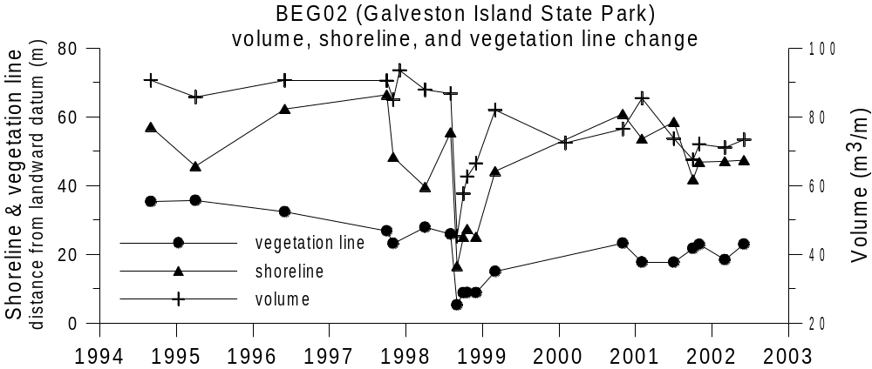

Figure 5. Profile volume, shoreline, and vegetation line changes at Galveston Island State Park.

At BEG08 on Follets Island southwest of San Luis Pass (Fig. 2), Frances eroded 33 m³/m of sand. The foredune was removed, leaving a former secondary dune as the foredune (see profiles in Appendix C). Only a small amount of washover sand was deposited through low areas in the former secondary dune. The shoreline retreated 50 m, and the vegetation line retreated 42 m. As at Galveston Island State Park, this beach began recovering soon after the storm, with 56% of the sand eroded returning by October 22, 6 weeks later (Fig. 6). By the end of the winter (March 1999), the beach volume was the same as before the storm. The shoreline advanced 31 m and the vegetation line moved 18 m seaward of its post-storm position. The recovery of volume and shoreline at BEG08 has been similar to the recovery at Galveston Island State Park. By February 2001 the volume and shoreline had stabilized near the prestorm values. The vegetation line and dune system on Follets Island at BEG08 have not been modified by humans since Tropical Storm Frances. The vegetation line continues to creep seaward and by the spring of 2002 was 24 m from its original post-storm position. Over the 2000-2002 monitoring period, a secondary vegetation line was recognized at this location as well. The seaward extent of this discontinuous second vegetation line is in approximately the same location as the prestorm vegetation line.

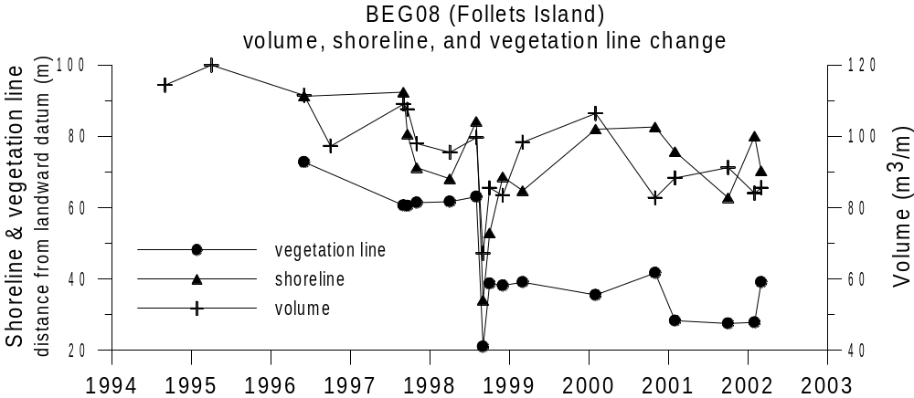

Figure 6. Profile volume, shoreline, and vegetation line changes on the northeast end of Follets Island.

Even though most of the sand removed by Frances returned to the beaches during the following winter, the shapes of the beaches have not completely recovered (see profiles in Appendix C). Dune formation and seaward advance of the vegetation line may take several years, and in some areas, the vegetation line may never return to its prestorm position before long-term erosion begins again. An artificial foredune was created at BEG02, whereas the BEG08 beach is natural. The human manipulation will have a significant impact on the beach and dune recovery, and continued monitoring of BEG02 and BEG08 by Ball High School will provide insight into the processes of natural and enhanced post-storm beach recovery.

The BEG02 beach profile at Galveston Island State Park is being incorporated into another study by Bureau scientists. The Bureau of Economic Geology is responsible for monitoring the impacts of geotextile tubes (geotubes) that have been installed along Galveston Island, Follets Island, and Bolivar Peninsula. Tropical Storm Frances placed many homes in this stretch of coast in danger of being damaged or destroyed during subsequent storms and gradual shoreline retreat. In an effort to prevent such damage from occurring, geotube storm protection projects were constructed as temporary erosion control measures. Part of the study is to determine effects of geotube projects to adjacent beaches, as well as determining beach width changes between geotube-backed beaches and beaches without these human-made structures. BEG02 is south of a geotube project in the Pirates Beach community.

Profiles measured by Port Aransas and Port Isabel students are the third in their time series. The beaches are distinctly different from one another and from the Ball High beaches. The Port Aransas profiles on Mustang Island have high foredunes, and a seawall backs the Port Isabel profiles (see profile plots in Appendix C) on South Padre Island. The beaches of Mustang Island appear to be relatively stable. The increase of 59 m³/m between February 2001 and March 2002 is due to a push-up pile of sand and sargassum adjacent to the foredune. The students at Port Isabel High School will be able to map trends on shoreline change due to nourishment projects that take place biannually in the northern section of the city of South Padre Island. A nourishment project was taking place during December of 2000, with another scheduled for December 2002. Although the sand from these nourishment projects is not placed on the beaches that are monitored by the high school students it may still have an impact later.

Future measurements by all three high schools will show not only change through time at each location but also spatial variation along the Texas coast. Through time the data collected from Galveston, Follets, Mustang, and South Padre Islands will help scientists establish a better understanding of the relationship between coastal processes, beach morphology, and shoreline change at these locations along the Texas coast.

CONCLUSIONS

The Texas High School Coastal Monitoring Program provides high school students with a real-world learning experience outside of the everyday classroom. The coastal monitoring program not only provides hands-on education but it also complies with many TEKS requirements. The 2001-2002 academic year was productive, with Ball and Port Aransas High Schools completing two field trips and Port Isabel High School collecting data on three field trips.

Ball High School students from Galveston, Texas, working with scientists from the Bureau of Economic Geology at The University of Texas at Austin have been taking scientific measurements at the beaches of Galveston and Follets Islands since 1997. During that time period, the students have been collecting data that record the recovery of the beaches following Tropical Storm Frances. Recovery of the beach at Galveston Island State Park is proceeding quickly following Frances owing partly to the construction of an artificial dune from washover sand. The site on Follets Island is recovering naturally and at a much slower rate. Continued data collection by students from Ball High School, as well as Port Aransas and Port Isabel High Schools, will help scientists, students, and the public gain a better understanding of coastal processes and shoreline change along the Texas coast.

RECOMMENDATIONS

We consider the fifth year of the coastal monitoring program a conditional success and offer the following recommendations for continuance and expansion of the program.

- Emphasize to the students that they are working on a real research project and are collecting scientifically valid data that will eventually appear in a scientific publication. This is a major point that makes this program different from most other field trips or laboratory exercises. Asking students to conduct experiments that have real consequences seems to make a difference to many students, and it probably improves the quality of the data.

- Clearly tell the students about the specific scientific problems being addressed, but also emphasize that what they are gaining in experience is not just how to measure beaches but how to conduct scientific field research in general. The students are also learning a different way to view their surroundings.

- Survey a reasonable number of beaches, which in most cases means two to three. The program goals of scientific research and science education could be at odds with one another. From a purely scientific point of view, it would be desirable to acquire as many data as possible. That approach, however, would not allow time for discussions on the beach that are not directly related to the measurements. It would also hinder the development of observation skills and keep the students from enjoying their work.

- The number of official field trips depends on the class, but a maximum of four trips is reasonable. Some trips may have to be cancelled because of bad weather or other unusual circumstances. Cancelled trips can be very difficult to reschedule. Therefore, some freedom must be allowed in the program regarding the number of trips and sites measured. Even if just one good data set is collected during the year it will be useful scientifically. Some students might be encouraged to make additional trips on weekends or after school. Interested students should be encouraged to use the program in a science fair project.

- When adding additional schools or a new teacher to the program, a 2- to 3-day seminar before the school year begins and including all the teachers is desirable. Instruction would be more efficient, and teachers and scientists would benefit by exchanging ideas.

- A Web site adds an important dimension to the project, especially when multiple schools are participating. A Web site at which students can exchange observations with other schools in Texas will increase the educational value of the program by allowing students to observe differences in the processes acting along the coast. A Web site would also introduce the Internet to students and illustrate how it can be used to conduct research. Furthermore, the Internet is important in increasing public awareness of coastal processes. Providing immediate feedback to students through the Internet is important. The students want to see their data and photographs on the Web, and feedback increases their interest in the project.
- Encourage the teachers to incorporate the data into the curriculum for their other classes. One of the goals of the program is to increase the awareness and understanding of the public to coastal processes and hazards. Disseminating data gathered by their peers may increase the interest of students not directly involved in the Coastal Monitoring Program. The data collected and knowledge gained from the analysis of the data are applicable to all Environmental Science, Geology, Aquatic Sciences, and Oceanography curricula.

APPENDIX A: PROFILE INFORMATION
Galveston Island and Follets Island profile coordinates are in NAD83. Heights Above the GRS80 Ellipsoid was converted to North American Vertical Datum 88 (NAVD88) using the Geiod99 Ellipsoid Model.
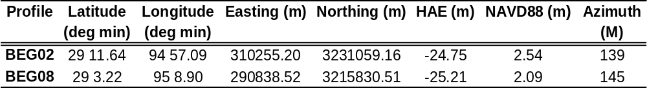

Mustang Island profile coordinates are in NAD83. Heights Above the GRS80 Ellipsoid was converted to North American Vertical Datum 88 (NAVD88) using the Geiod99 Ellipsoid Model.
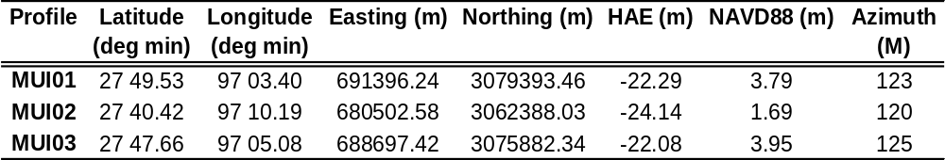

South Padre Island profile coordinates are in NAD83. Heights Above the GRS80 Ellipsoid was converted to North American Vertical Datum 88 (NAVD88) using the Geiod99 Ellipsoid Model.
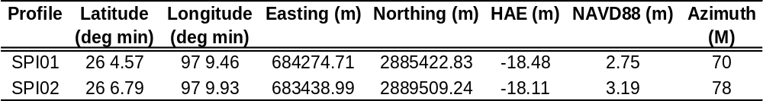

APPENDIX B: GRAPHS OF VOLUME, SHORELINE, AND VEGETATION LINE CHANGE

MUI01 volumes are calculated from datum to 3 m below datum. Profiles that did not extend to –3 m were extrapolated.

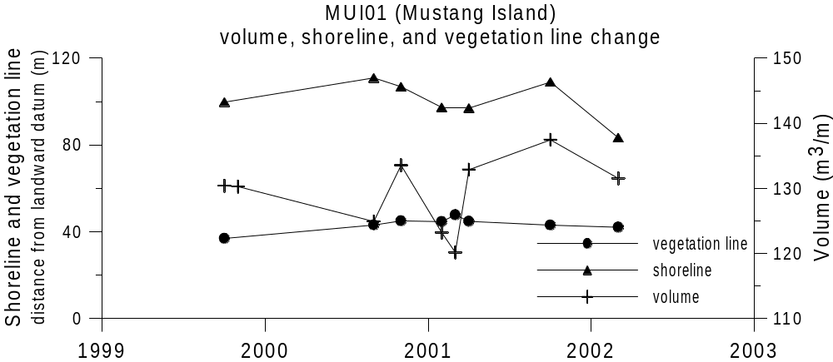

MUI02 volumes were calculated from datum to 1 m below datum. Profiles that did not extend to –1 m were extrapolated.

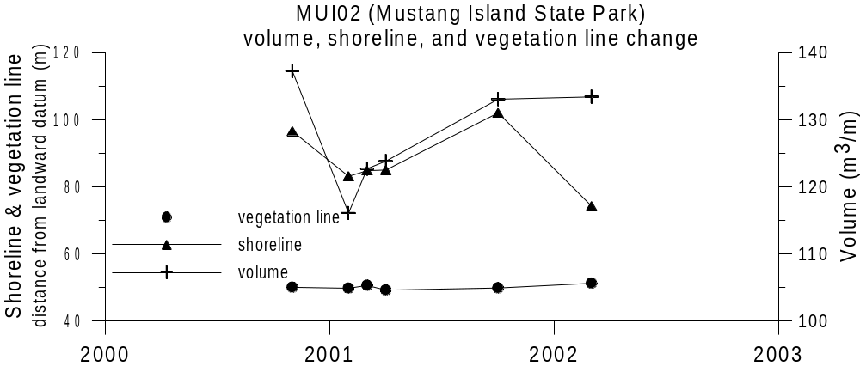
MUI03 volumes were calculated from datum to 3.25 m below datum. Profiles that did not extend to –3.25 m were extrapolated.

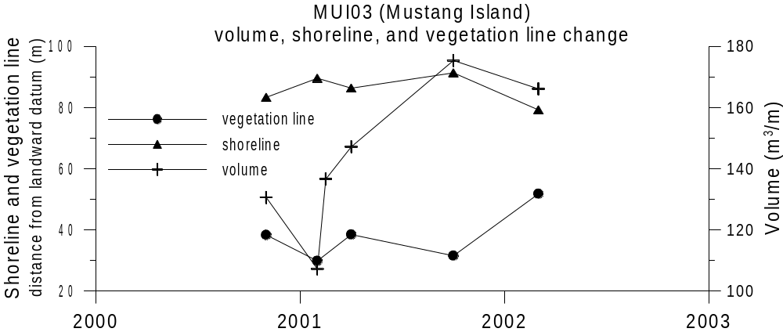
SPI01 volumes were calculated from datum to 2.25 m below datum. Profiles that did not extend to –2.25 m were extrapolated.

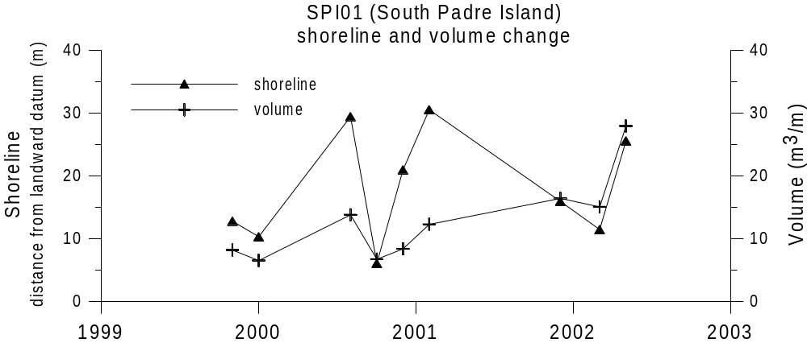

SPI02 volumes were calculated from datum to 2.5 m below datum. Profiles that did not extend to –2.5 m depth were extrapolated.

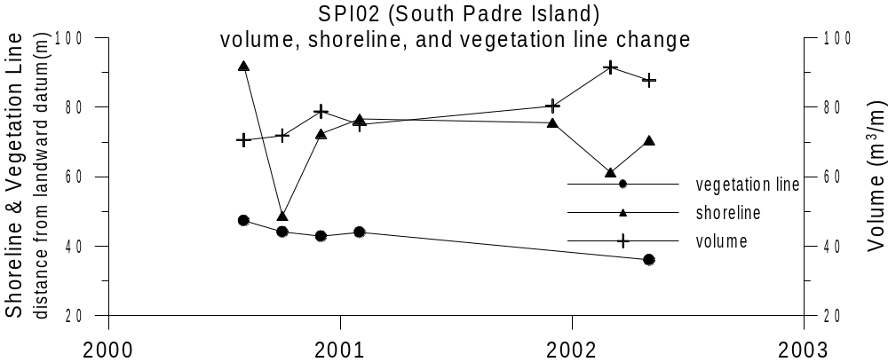

APPENDIX C: graphs of BEACH PROFILES


