Sand Analysis Next Previous Back

Step 1: Taking Beach Sediment Samples

Equipment:

- Sample cups; three(3) per profile
- Permanent ink marker

A. Take one sand sample from the foredune, berm top, and beachface areas. See Figure 1.

B. Take the samples during the measurement of the beach profile along the profile line. Note on the beach profile form the point at which you take the samples.
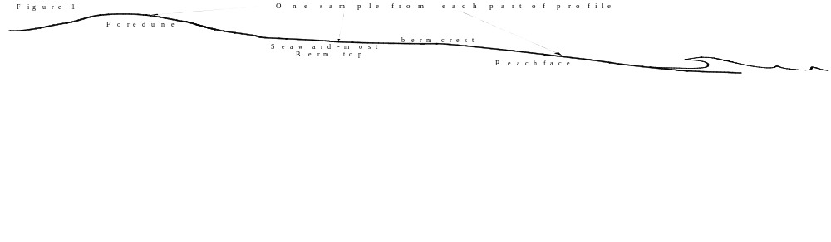

C. Pick an undisturbed area and push a small plastic sample cup into the sand. Carefully pull the cup out and place the lid on.

D. LABEL SAMPLE: With an ink marker write the following information on the sample cup label (see figure 2 below):
- Profile name: e.g. BEG08.
- Sample location: Foredune (FD), Berm Top (TB), or Beachface (BF)
- Date (Year/Month/Day) and time: e.g. 1997/09/23 13:30

Sample number: e.g. BEG08-BF-19970923
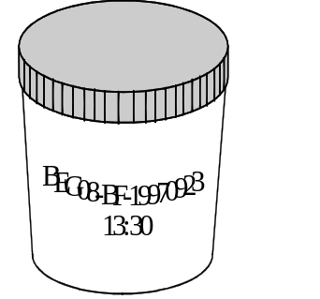
Step 2: Sample Preparation

Equipment:

- Large beaker/cup
- Pencil/ink marker
- Filter paper
- Funnel
- Ohaus balance
- Clean water
- Access to sink
- Stirring rod
- Worksheet

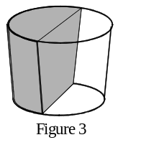
A. Label the beaker with the sample number.

B. Weigh the empty beaker. Note the weight.

C. Place Sample in Beaker: Open your sample cup and put half of the sample into the beaker. Split the sample in half depth-wise as in figure 3 above.

D. Wash the sample: Fill the beaker with water and stir the sample until all the sediment is in "suspension", i.e. swirling around in the beaker. Stop stirring and allow 15 minutes for the sediment to settle to the bottom of the beaker.

E. Dry the sample: If the water is still clear, you have little or no clay in your sample. Carefully "decant" (pour out) as much of the water as possible without loosing any of the sediment. Set the beaker aside and let the sample dry completely. When the sample is completely dry, go to Step 3: Sieving.

F. Decant/filter the clay fraction: If the water is muddy after the sediment has settled for 15 minutes, then you have clay in your sample. This clay should be removed before you sieve the sample, otherwise the wire screens may clog.
- Write the sample number on the filter paper. Weigh the filter paper. Note the weight. Put the paper into the funnel and place the funnel over the sink.
- Carefully pour most of the muddy water through the filter paper. The paper should trap the clay suspended in the water. Don't pour any sand in the funnel.
- Add more water to the beaker. Stir vigorously and then wait 15 minutes for the sediment to settle to the bottom of the beaker.
- Again pour the muddy water through the filter paper.
- Repeat the process of adding water, stirring, and filtering until the water in the beaker is clear.
- Remove the filter paper from the funnel. Set the paper aside and let it dry.
- Set the sediment sample in the beaker aside and let it dry completely.
Step 3: Sieving

Equipment:

- Keck Sand Shaker
- Worksheet

- Pencil or ink marker
- Seven (7) shallow containers; e.g.
petri-type dishes or cups.

Sieving is the sorting of sediment by grain size using wire screens of differing mesh. Sort your sample into 7 size categories using the Keck Sand Shaker (figure 4) and the wire screens stamped with the following numbers:
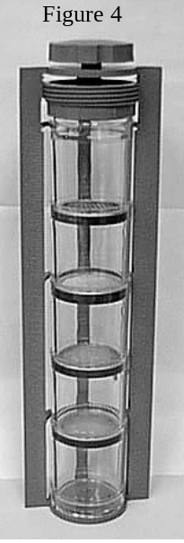
Sieve stamp # Grain Size Grain diameter
Gravel
72 ------------------------------------------------------ 2 mm
Very coarse sand
40 ------------------------------------------------------ 1 mm
Coarse sand
20 ----------------------------------------------------- 0.5 mm
Medium sand
09 ---------------------------------------------------- 0.25 mm
Fine sand
046 ------------------------------------------------- 0.125 mm
Very fine sand
024 ------------------------------------------------ 0.0625 mm
Silt

The sieving will be done in two stages. The first sieving will sort the sediment into gravel, sand, and silt. The second sieving will sort the sand into very coarse sand, coarse sand, medium sand, fine sand, and very fine sand.

A. Weigh the beaker and sample from Step 2. Note the weight on the worksheet.

B. Label the seven containers with the sample number. Also label each container with a grain size: "gravel", "very coarse sand", "coarse sand", "medium sand"," fine sand", "very fine sand", or "silt".

C. Weigh the seven containers and note their weights on the worksheet.

D. Clean sieves: Disassemble the Sand Shaker and clean out the plastic cylinders and the screens.

E. Assemble the Sand Shaker:
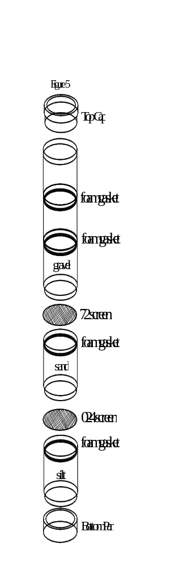
- Place the clear plastic bottom pan on a table. Now stack four plastic cylinders with black foam rings on the bottom pan. Place the 024 and 72 screens in the bottom two cylinders. Place the screens on top of a foam gasket as shown by the figure 5 at right.
- Place the fifth cylinder with no foam ring on the stack.
- Pour your weighed sample into the top cylinder.
- Place the clear plastic cap on top of the stack.
- Carefully insert the stack into the frame of the Sand Shaker. You may have to squeeze the stack slightly to compress the foam rings in order to slide the stack into the frame.
- While holding the stack of cylinders in the frame with one hand, turn the knob on top of the frame clockwise to secure the stack within the frame.

F. Sieve gravel, sand and silt:
- Hold the Sand Shaker frame firmly at the top and the bottom and shake up and down for three (3) minutes; occasionally tapping the bottom of the frame.
- After the sediment has been distributed in the cylinders, set the Sand Shaker back on the table.
- Turn the knob counterclockwise to release the stack from the frame.
- Carefully slip the stack out of the frame, holding the stack at the bottom pan and top plug.
- Now, this is the tricky part. Hold the stack over the empty "silt" container, release the bottom pan and allow the silt in the bottom cylinder to fall into the container.
- Move the stack over one of the empty "sand" container and allow the sand in the second cylinder to fall out.
- Move the stack over the "gravel" container and allow the gravel (if any) to fall out of the third cylinder.

G. Reassemble the Sand Shaker: Reassemble the Sand Shaker using four screens as shown in figure 6 on the right; 40, 20, 09, and 046.
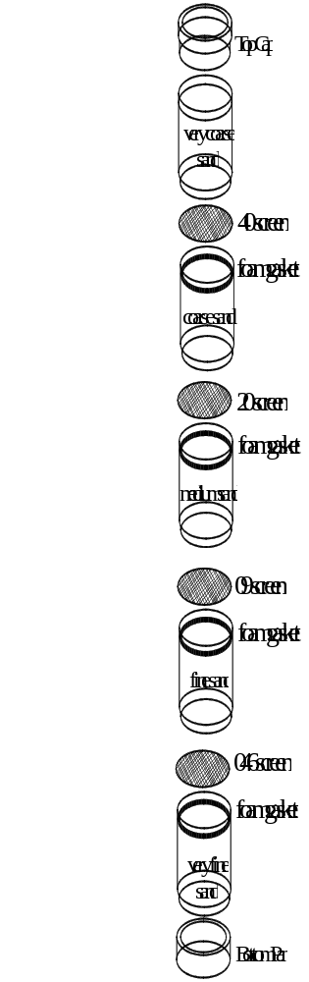

H. Sieve the sand: Pour the sand from D into the top of the Sand Shake and re-sieve the sand into sub-categories. Carefully empty the contents of each cylinder into the containers labeled "very coarse sand", "coarse sand", "medium sand"," fine sand", and "very fine sand".
Step 4: Weighing

Equipment

- Ohaus balance
- Worksheet
- Pen/pencil
- Calculator

You now have seven containers with different amounts of sediment: gravel, very coarse sand, coarse sand, medium sand, fine sand, very fine sand, and silt. You may also have a filter paper coated with clay. In step 3 you labeled and weighted each container empty. You now need to weight each container with its size fraction to estimate the proportion of each grain size in the original sample.

A. Place each container in turn on the scale and note it's weight.

B. Weight the filter paper if you decanted the clays in your sample.

C. Calculate the weight of each of grain size fractions. Do this by subtracting the empty weight of a container from its "full" weight. Note the difference in the worksheet.

D. Add up the weights of all size fractions. Note this sum in the worksheet.

E. Calculate the percentage of each size fraction using the simple equation:
% = weight of size fraction x 100
total weight of sample
Note the percentage in the worksheet.

Step 5: Grain Type Analysis
Equipment:

- Hands lens
- Geotechnical Gauge
- Magnet
- 10% HCL
- Worksheet
- Pen/pencil

Shape and rounding: Beach sediments have typically traveled some distance from a sediment source to their present location on the beach. The sediment source could be quite close (sea shells washed ashore) or a granite peak half a continent away. As wind, rivers, and ocean currents carry sediment grains, abrasion and collisions tend to break and smooth the grains. Grains are further smoothed on the beach as they are washed back and forth by waves.

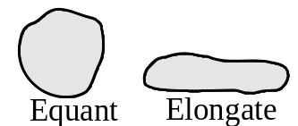Closely examine the grains in each size fraction with your hand lens or under a low-power binocular microscope. What shape do the grains tend to be ? Equant or elongate ? Are the grains angular or rounded ? Angular grains have sharp corners and projections. Rounded grains have no corners or projections. Use your hand lens and the Geotechnical Gauge to decide whether the grains in each size fraction tend to be either very angular, angular, sub-angular, sub-rounded, rounded, or well rounded.
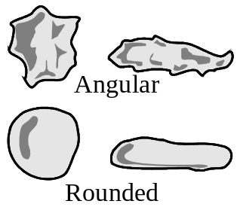

Color. Color is an important clue in understanding the composition of rocks. Certain colors point to the presence of a particular mineral or chemical component. For example, a brown or yellowish hue is often associated with the presence of oxidized iron (Fe⁺³). Conversely, reduced iron (Fe⁺²) can give a rock or sediment a green color. The presence of organic carbon, the remains of plant and animal matter, typically colors rocks either gray or black.

What is the general color of each size fraction ? Use you hand lens and examine the grains more closely. Are the grains alike in color or are some grains distinctly different ? What is the color of any mud ?

Magnetism: Some minerals are magnetic. Pass a magnet through each size fraction and note the presence of any magnetic grains. Are magnetic particles restricted to one size fraction or are they evenly distributed among all size fractions ?

Quartz versus calcite: Two very common minerals are quartz (SiO₂) and calcite (CaCO₃). Limestone is composed of calcite as are many sea shells. Examine your sediment under the hand lens or binocular microscope and see if you can identify any shell fragments in your sand and gravel fractions. Calcite is soluble in weak acid but quartz is not. Place a drop of dilute HCL or vinegar on each size fraction and see if any grains fizz. Use your hand lens and note which grains react with acid. Try to estimate the percentage of shell fragments (calcite grains) in each size fraction.

If you filtered a mud fraction from your sample, see if it fizzes. Does it fizz weakly or strongly ? Note down any reaction of the mud fraction with acid.
Sample No: ___________________ Sample Date: ____________ Time: ______
Profile: ______________________ Sample Location: _____________________
Students: ____________________________________ School: _____________

Beaker + dry sample weight ________ gm
Empty beaker weight ________ gm
dry sample weight ________ gm

A. Container B. Container Amount % of
Empty Full (B minus A) Total
Gravel _______ _______ _______ ______
V. coarse sand _______ _______ _______ ______
Coarse sand _______ _______ _______ ______
Medium sand _______ _______ _______ ______
Fine sand _______ _______ _______ ______
V. fine sand _______ _______ _______ ______
Silt _______ _______ _______ ______
Clay _______ _______ _______ ______
Total weight: _______ gm 100%

Grain Grain Magnetic % calcite
Shape rounding Color minerals or shell
Gravel _______ ___________ _______ _______ ______
V. coarse sand _______ ___________ _______ _______ ______
Coarse sand _______ ___________ _______ _______ ______
Medium sand _______ ___________ _______ _______ ______
Fine sand _______ ___________ _______ _______ ______
V. fine sand _______ ___________ _______ _______ ______
Silt _______ ______ ______
Clay _______ ______

